User Testing: admin.py

This document provides comprehensive testing for the admin.py script. Test data includes all possible inputs, whether valid or invalid.

# Login

When admin.py is run, the user is prompted to enter a username and password. If the username or password entered is incorrect, the program will terminate. If both the username and password entered are correct, the program will proceed on to the admin menu.

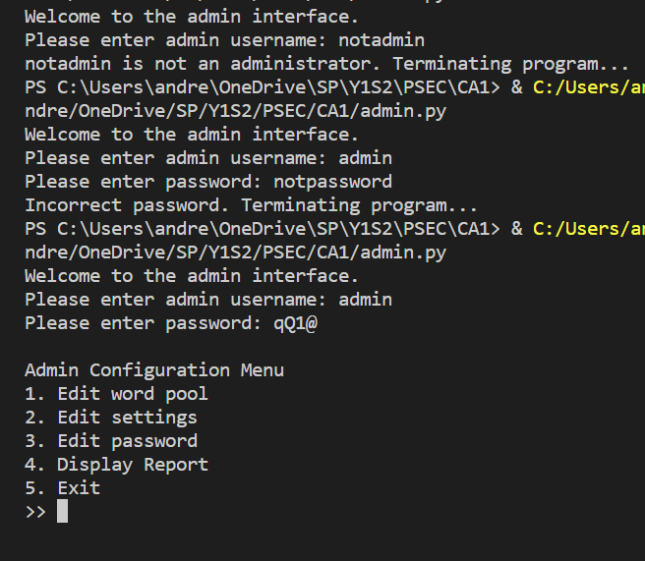

# Admin Menu

The admin menu has 4 administrator options as well as 1 exit option and prompts for an input. Invalid inputs will cause the menu to continue prompting for an input until a valid input is entered (1-5). A valid input will bring the user to the selected function.

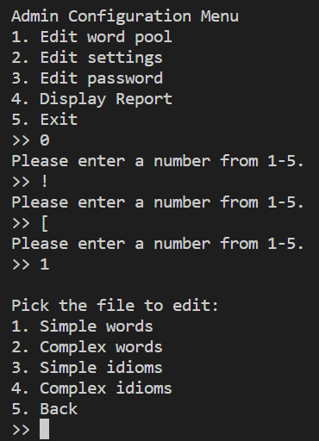

# 1. Edit word pool

Option 1 of the admin menu, ‘Edit word pool’, prompts the user to pick one of 4 word pools to edit or go ‘Back’. Invalid inputs will cause the menu to continue prompting for an input until a valid input is entered (1-5). A valid input will allow the user to edit the selected file.

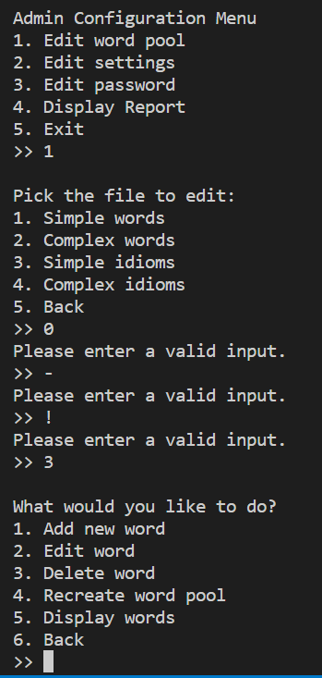

After selecting a word pool, the user can pick 1 of 5 edit options or a ‘Back’ option. Invalid inputs will cause the menu to continue prompting for an input until a valid input is entered (1-6). A valid input will allow the user to perform the selected edit.

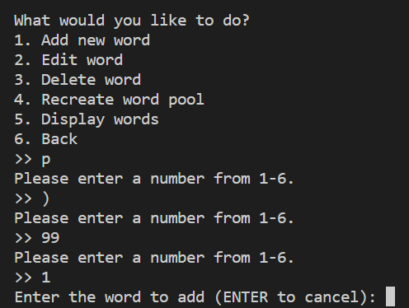

# 1. Edit word pool > 1. Add new word

Option 1 of Edit word pool, ‘Add new word’, prompts the user for a new word to add to the word pool.

If the user inputs [ENTER], operation is cancelled and it returns to admin menu

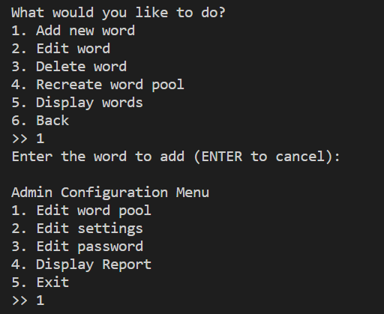

If the user inputs a word/idiom, e.g. ‘love is blind’, the program prompts for a definition for the word/idiom. The user can then enter ‘Y’ to confirm the entry or enter ‘N’ to cancel the entry. Both options will lead back to the admin menu. If the word is already in the word pool, program returns to admin menu

‘N’ to cancel entry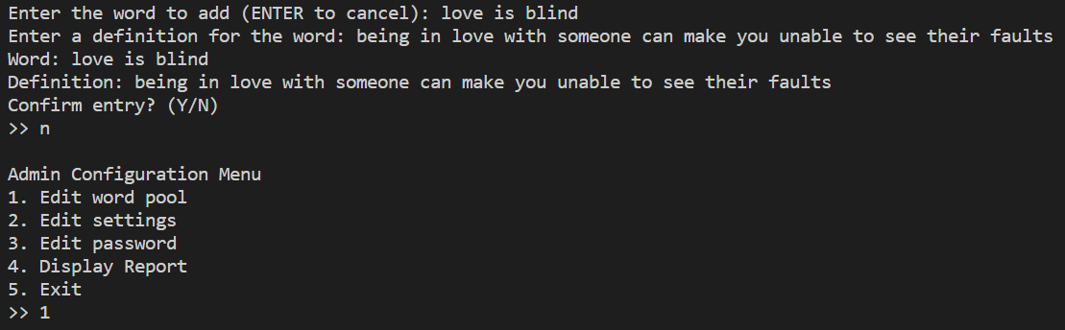

‘Y’ to confirm entry

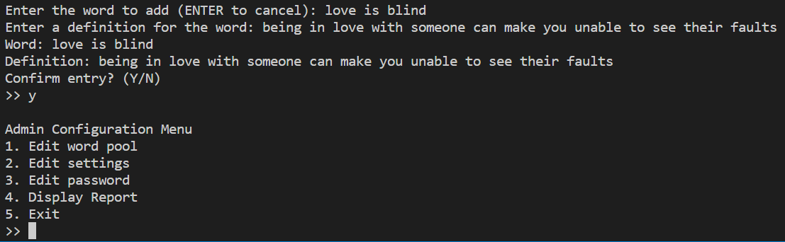

If word already exists in word pool:

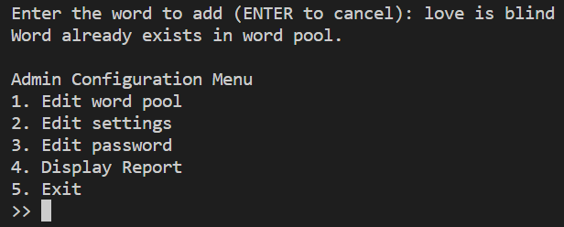

# 1. Edit word pool > 2. Edit word

Option 2 of Edit word pool, ‘Edit word’, prompts the user for a word to edit.

If the word does not exist in word pool:

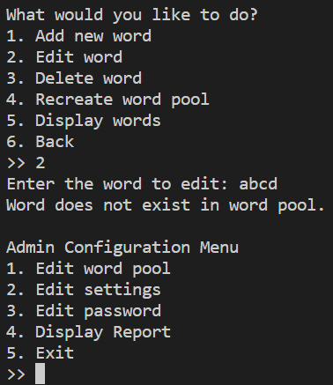

If the word exists, pick whether to edit spelling or definition:

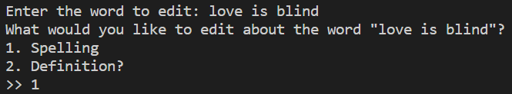

If spelling is picked, program prompts for new spelling and writes into file:



If definition is picked, program prompts for new definition and writes into file:



# 1. Edit word pool > 3. Delete word

Option 3 of Edit word pool, ‘Delete word’, prompts the user for a word to delete.

If the word does not exist in word pool:

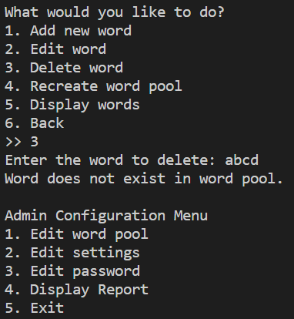

If the word exists in word pool:

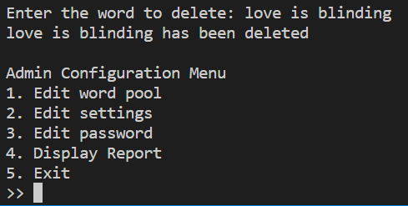

# 1. Edit word pool > 4. Recreate word pool

Option 4 of Edit word pool, ‘Recreate word pool’, continuously prompts for a new word and definition until the user enters [ENTER] to save and quit.

‘Y’ to confirm new word pool

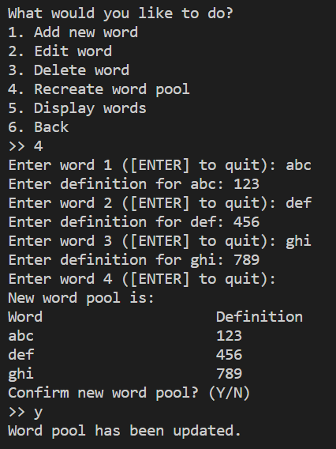

‘N’ to cancel operation

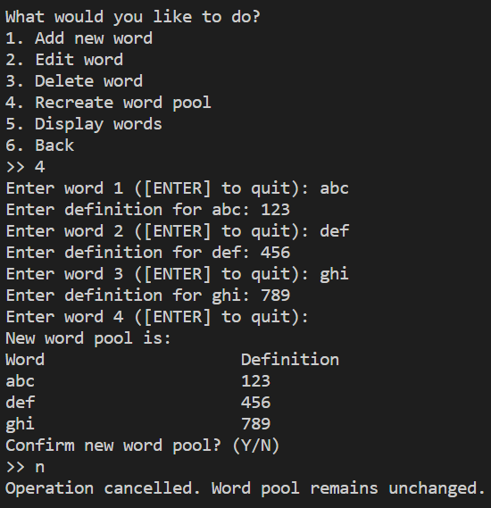

# 1. Edit word pool > 5. Display word pool

Option 4 of Edit word pool, ‘Display word pool’ displays all words and definitions in the word pool

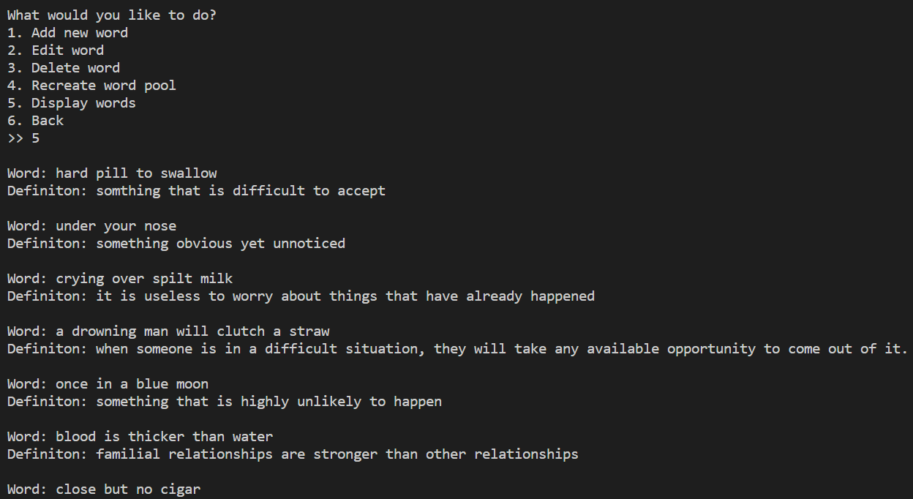

# 2. Edit settings

Option 2 of the admin menu, ‘Edit settings’, prompts the user to pick a setting to edit and the new value to change it to.

Invalid inputs will cause the program to keep prompting until a valid input is entered.

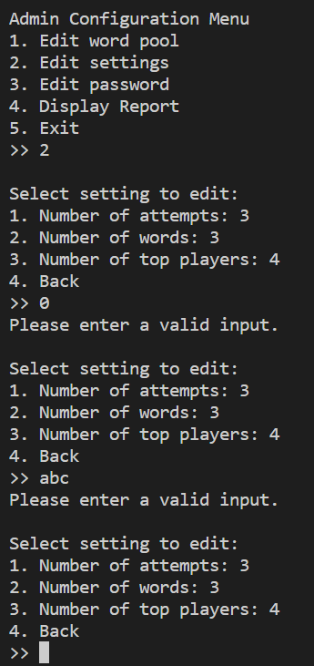

A valid input prompts the user for the new value of the setting and ‘4’ returns user to admin menu

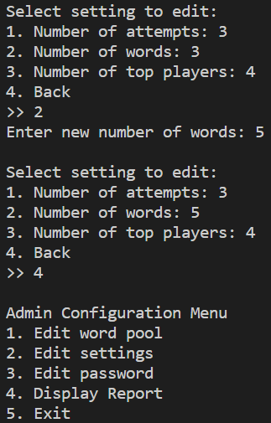

# 3. Edit password

Option 3 of the admin menu, ‘Edit password’, prompts the user to enter the password. If the correct password is entered, it then prompts for a new password.

If user inputs incorrect current password:

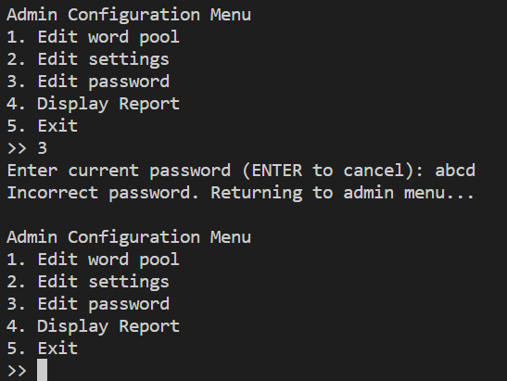

If user inputs correct current password:

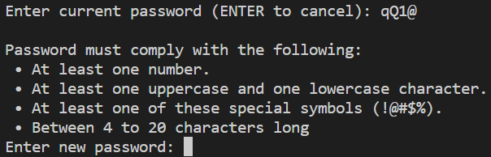

Program prompts for new password until a valid password that matches the criteria is entered:

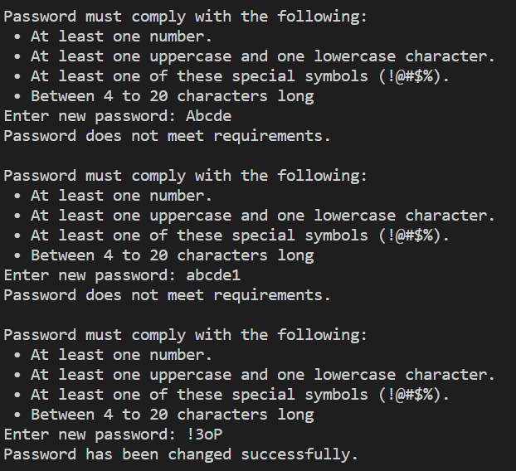

# 4. Display report

Option 4 of the admin menu, ‘Display report’, prompts the user to enter a start and end date. Invalid inputs will cause the program to keep prompting until both inputs are valid. A valid input will display the game logs between the dates entered.

Invalid inputs:

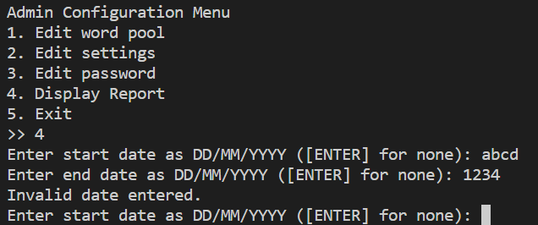

Valid inputs:

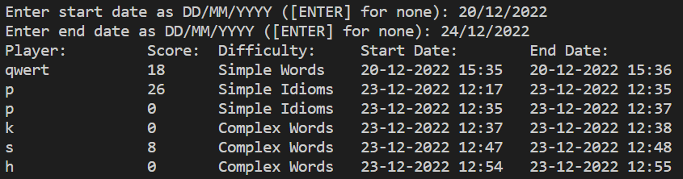

Blank input for either date:

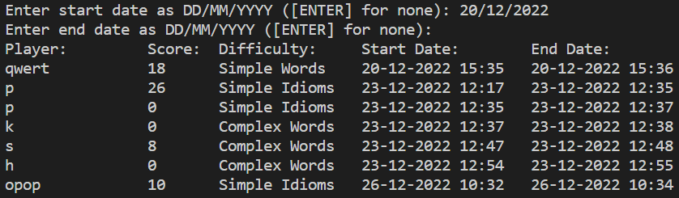

# 5. Exit

Option 5 of the admin menu, ‘Exit’, terminates the program.

